Practical 1 – Implementation of Substitution Techniques Practical

1A Aim: To implement Caesar Cipher
Code:
import java.io.*;
class Prac1A
{
public static void main(String args[])
{
int i;
try
{
File f1 = new File("1.txt");
File f2 = new File("2.txt");
File f3 = new File("3.txt");
FileInputStream fis = new FileInputStream(f1);
FileOutputStream fos = new FileOutputStream(f2);
FileOutputStream os = new FileOutputStream(f3);
while((i=fis.read()) != -1)
{
fos.write(i);
os.write(i+6);
}
System.out.println("File copied");
}
catch(Exception e)
{
e.printStackTrace();
}}}
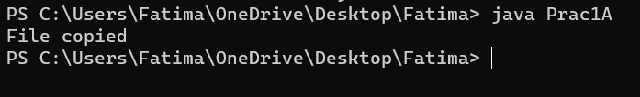
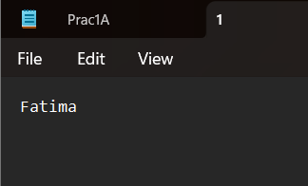
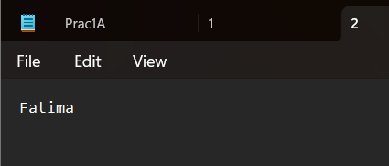
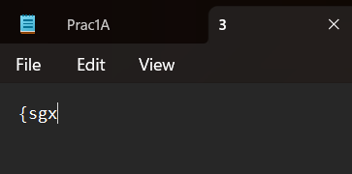

Practical 1B

Aim: To implement Modified Caesar Cipher
Code:
import java.io.*;
class prac1b
{
public String Encrypt(int shift, String line)
{
String result = "";
int offset;
for(int i=0;i<line.length();i++)
{
offset = ((int)line.charAt(i)+shift)%256;
result += (char)(offset);
}
return result;
}
public String Decrypt(int shift, String line)
{
String result = "";
int offset;
for(int i=0;i<line.length();i++)
{
offset = ((int)line.charAt(i)-shift)%256;
if(offset<0)
{
offset+= 256;
}
result+= (char)(offset);
}
return result;
}
public static void main(String args[])
throws IOException
{prac1b b = new prac1b();
BufferedReader br = new BufferedReader(new
InputStreamReader(System.in));
int choice;
System.out.println("Menu:\n1: Encryption\n2: Decryption");
choice = Integer.parseInt(br.readLine());
System.out.println("Enter the shift");
int shift = Integer.parseInt(br.readLine());
System.out.println("Enter the line");
String line = br.readLine();
System.out.println("Result: ");
switch(choice)
{
case 1:
{
System.out.println(b.Encrypt(shift, line));
break;
}
case 2:
{
System.out.println(b.Decrypt(shift, line));
break;
}
default:
{
System.out.println("Invalid choice");
}}}}
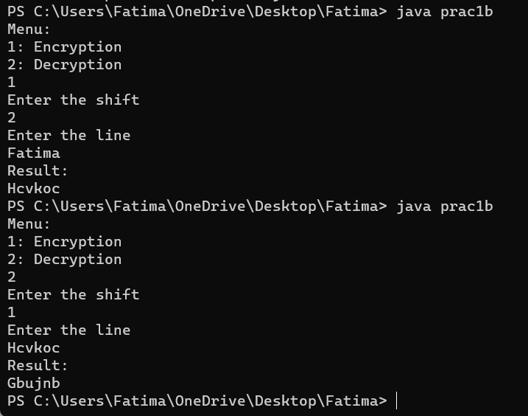

Practical 1C

Aim: To implement Mono-alphabetic Cipher
Code:
import java.util.Scanner;
public class prac1c
{
public static char p[] =
{'a','b','c','d','e','f','g','h','i','j','k','l','m','n','o','p','q'
,'r','s','t','u','v','w','x','y','z'};
public static char ch[] =
{'Q','W','E','R','T','Y','U','I','O','P','A','S','D','F','G','H','J'
,'K','L','Z','X','C','V','B','N','M'};
public static String doEncryption(String s)
{
char c[] = new char[(s.length())];
for(int i=0;i<s.length();i++)
{
for(int j=0;j<26;j++)
{
if(p[j]==s.charAt(i))
{
c[i] = ch[j];
break;
}
}
}
return (new String(c));
}
public static String doDecryption(String s)
{
char p1[] = new char[(s.length())];
for(int i=0;i<s.length();i++)
{
for(int j=0;j<26;j++)
{
if(ch[j] == s.charAt(i))
{
p1[i] = p[j];
break;
}
}
}
return(new String(p1));
}
public static void main(String args[])
{
Scanner sc = new Scanner(System.in);
System.out.println("Enter the message");
String en = doEncryption(sc.next().toLowerCase());
System.out.println("Encrypted message: " + en);
System.out.println("Decrypted message: " +
doDecryption(en));
sc.close();
}}

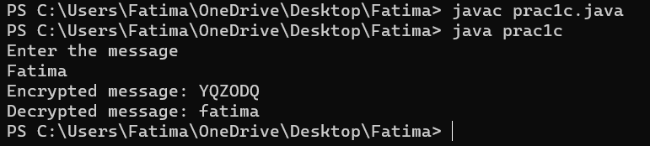

Practical 2 – Implementation of Transposition Techniques
Practical 2A

Aim: To implement Rail-Fence Technique
Code:
class prac2a
{
public static void main(String args[])
{
String input = "hey, I'm Fatima";
String output = "";
int len = input.length();
System.out.println("Input string: " + input);
for(int i=0;i<len;i+=2)
{
output += input.charAt(i);
}
System.out.println("Cipher text: " +output);
}}
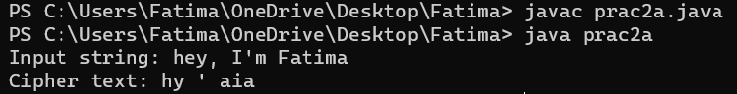

Practical 2B

Aim: To implement Vernam Cipher
Code:
import java.lang.Math;
public class prac2b
{public static void main(String args[])
{String str = new String("Fatima");
char[] arText = str.toCharArray();
String cipher = new String("ARMA");
char[] arCipher = cipher.toCharArray();
char[] encoded = new char[4];
System.out.println("Encoded to be..");
for(int i=0;i<arText.length;i++)
{encoded[i] = (char)(arText[i] ^ arCipher[i]);
System.out.println(encoded[i]);
}
System.out.println("\nDecoded to be..");
for(int i=0;i<encoded.length; i++)
{
char tem = (char)(encoded[i] ^ arCipher[i]);
System.out.println(tem);
}}}

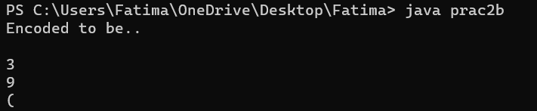

Practical 3

Aim: To implement Diffie-Hellman’s Key Exchange Algorithm
Code:
import java.math.BigInteger;
import java.security.KeyFactory;
import java.security.KeyPair;
import java.util.*;
import java.math.BigInteger.*;
import java.math.*;
class prac3
{public static void main(String args[])
{BigInteger a,b,k1,k2,x,y,g,n;
Scanner s = new Scanner(System.in);
System.out.println("Enter A's prime number");
n = s.nextBigInteger();
System.out.println("Enter B's prime number");
g = s.nextBigInteger();
System.out.println("Enter A's secret key");
x = s.nextBigInteger();
System.out.println("This key is sent to B");
System.out.println("Enter B's secret key");
y = s.nextBigInteger();
System.out.println("This key is sent to A");
a = g.modPow(x,n);
b = g.modPow(y,n);
k1 = b.modPow(x,n);
k2 = a.modPow(y,n);
System.out.println("A's key is " + k1);
System.out.println("B's key is " + k2);}}
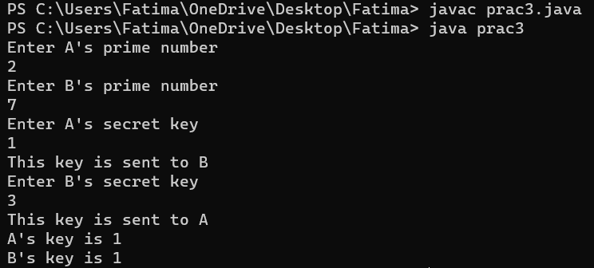

Practical 4

Aim: To implement Data Encryption Standard Algorithm
Code:
import javax.crypto.*;
import java.io.*;
import java.security.InvalidAlgorithmParameterException;
import java.security.spec.*;
import java.lang.*;
import javax.crypto.spec.IvParameterSpec;
public class prac4
{Cipher ecipher;
Cipher dcipher;
prac4(SecretKey key)
{try
{ecipher = Cipher.getInstance("DES");dcipher = Cipher.getInstance("DES");ecipher.init(Cipher.ENCRYPT_MODE,key);dcipher.init(Cipher.DECRYPT_MODE,key);
}
catch(javax.crypto.NoSuchPaddingException e)
{}
catch(java.security.NoSuchAlgorithmException e)
{}
catch(java.security.InvalidKeyException e)
{}}
public String Encrypt(String str)
{try
{byte[] utf8 = str.getBytes("UTF8");
byte[] enc = ecipher.doFinal(utf8);
return new sun.misc.BASE64Encoder().encode(enc);
}
catch(javax.crypto.BadPaddingException e)
{}
catch(IllegalBlockSizeException e)
{}
catch(UnsupportedEncodingException e)
{}
catch(java.io.IOException e)
{}
return null;
}
public String Decrypt(String str)
{try
{byte[] dec = new sun.misc.BASE64Decoder().decodeBuffer(str);
byte[] utf8 = dcipher.doFinal(dec);
return new String(utf8,"UTF8");}
catch(javax.crypto.BadPaddingException e)
{}
catch(IllegalBlockSizeException e)
{}
catch(UnsupportedEncodingException e)
{}
catch(java.io.IOException e)
{}
return null;
}
public static void main(String args[])
{
System.out.println();
System.out.println("Encrypting string using DES Algorithm");
System.out.println();
try
{
SecretKey key =
KeyGenerator.getInstance("DES").generateKey();
prac4 encrypter = new prac4(key);
String s = "Fatima";
String d = "Hello";
String encrypted = encrypter.Encrypt(s);
String decrypted = encrypter.Decrypt(encrypted);
System.out.println("Original:" + s);
System.out.println("Encrypt:" + encrypted);
System.out.println("Decrypt:" + decrypted);
}
catch(Exception e)
{
}
}
}
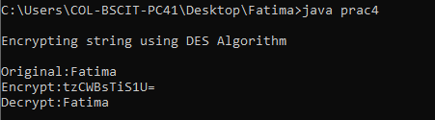

Practical 5

Aim: To implement Advanced Encrypting Standard Algorithm
Code:
import java.security.*;
import javax.crypto.*;
import java.io.*;
public class prac5
{
Cipher ecipher;
Cipher dcipher;
prac5(SecretKey key)
{
try
{
ecipher = Cipher.getInstance("AES");
dcipher = Cipher.getInstance("AES");
ecipher.init(Cipher.ENCRYPT_MODE, key);
dcipher.init(Cipher.DECRYPT_MODE, key);
}
catch(Exception e)
{
System.out.println(e.getMessage());
}
}
public String Encrypt(String str)
{
try
{
byte[] utf8 = str.getBytes("UTF8");
byte[] enc = ecipher.doFinal(utf8);
return new sun.misc.BASE64Encoder().encode(enc);
}
catch(Exception e)
{
e.printStackTrace();
}
return null;
}
public String Decrypt(String str)
{
try
{
byte[] dec = new
sun.misc.BASE64Decoder().decodeBuffer(str);
byte[] utf8 = dcipher.doFinal(dec);
return new String(utf8,"UTF8");
}
catch(Exception e)
{
System.out.println(e.getMessage());
}
return null;
}
public static void main(String[] args)
{
SecretKey key = null;
try
{
KeyGenerator keyGen =
KeyGenerator.getInstance("AES");
key = keyGen.generateKey();
}
catch(Exception e)
{
e.printStackTrace();
}
prac5 dese = new prac5(key);
String o = "Fatima" ;
String e = dese.Encrypt(o);
String d = dese.Decrypt(e);
System.out.println(o);
System.out.println(e);
System.out.println(d);
}}
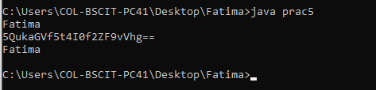

Practical 6

Aim: To implement RSA (Rivest Shamir Adleman) Algorithm
Code:
import java.math.*;
import java.security.*;
public class Prac6
{
BigInteger p,q,n,d,e,ph,t;
SecureRandom r;
public Prac6()
{
r = new SecureRandom();
p = new BigInteger(2,0,r);
q = new BigInteger(2,0,r);
System.out.println("Prime numbers p and q are " +p.intValue() + ", " + q.intValue());n = p.multiply(q);
ph = (p.subtract(new BigInteger("1")));
ph = ph.multiply(q.subtract(new BigInteger("1")));
e = new BigInteger("2");
while(ph.gcd(e).intValue()>1 || e.compareTo(ph)!=-1)
{

e = e.add(new BigInteger("1"));
d = e.modInverse(ph);
System.out.println("Public key is ("+n.intValue() + "," + e.intValue()+")");
System.out.println("Private key is ("+n.intValue() + "," + d.intValue()+")");
BigInteger msg = new BigInteger("15");
System.out.println("\nMessage is: " +msg);
BigInteger enmsg = encrypt(msg,e,n);
System.out.println("\nEncrypted Messageis: " + enmsg.intValue());
BigInteger demsg = decrypt(msg,e,n);
System.out.println("\nDecrypted Messageis: " + demsg.intValue());
}
}
BigInteger encrypt(BigInteger msg, BigInteger e, BigInteger n)
{
return msg.modPow(e,n);
}
BigInteger decrypt(BigInteger msg, BigInteger d, BigInteger n)
{
return msg.modPow(d,n);
}
public static void main(String args[])
{
Prac6 r = new Prac6();
}
}

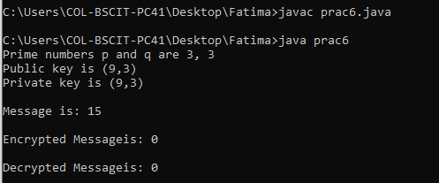
Practical 7

Aim: To implement RC4 (Rivest Cipher 4) Algorithm
Code:
class Prac7
{
String pt;
static char cipher[];
Prac7(String pt, int[] key)
{
this.pt = pt;
int s[] = new int[255];
cipher = new char[pt.length()];

for(int i=0;i<s.length;i++)
{
s[i] = i;
}
int i = 0;
int j = 0;
for(int k=0;k<pt.length();k++)
{
int modk = (k%key.length);
int kc = key[modk];
j = (s[i]+j+kc)%256+1;
int temp = s[i];
s[i] = s[j];
s[j] = temp;
int sc = (s[i]+s[j])%256;
int ck = s[sc];
cipher[k] = (char)(ck^(int)pt.charAt(k));
i = i+1;
}
}
public static void main(String args[])
{
int k[] = {1,2,3,4,5};
String original = "Fatima";
System.out.println("Value is: " + original);
new Prac7(original, k);
for(int i=0;i<cipher.length;i++)
{
System.out.println(" " + cipher[i]);
}
}
}

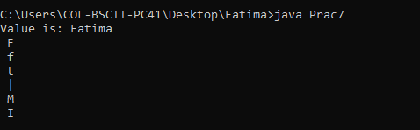

Practical 8

Aim: To implement Blowfish Algorithm
Code:
import javax.crypto.Cipher;
import javax.crypto.KeyGenerator;
import javax.crypto.SecretKey;
import javax.swing.JOptionPane;
public class Prac8
{
public static void main(String args[])
throws Exception
{
KeyGenerator keygen =
KeyGenerator.getInstance("Blowfish");
SecretKey secretkey = keygen.generateKey();
Cipher cip = Cipher.getInstance("Blowfish");
cip.init(Cipher.ENCRYPT_MODE, secretkey);
String inputText = JOptionPane.showInputDialog("Give input");
byte[] encrypted = cip.doFinal(inputText.getBytes());
cip.init(Cipher.DECRYPT_MODE, secretkey);
byte[] decrypted = cip.doFinal(encrypted);
JOptionPane.showMessageDialog(JOptionPane.getRootFrame(),
"Encrypted: " + new String(encrypted) +"\n" + "Decrypted:" + new
String(decrypted));
System.exit(0);
}
}
